Objective: Synthetic Process Workload Generation and Simulation
Update: Reference solution hereDownload here.
Update: Reference slide for probability hereDownload here.
Task: Implement a discrete workload generator that synthesizes the execution schedule of 1000 distinct processes.
- The arrival of processes in a real-world system is often modeled as a Poisson Process, meaning that the time interval between consecutive process arrivals (the inter-arrival times) is exponentially distributed.
- The CPU service time requested by each process is also modeled using an Exponential distribution.
- For this demonstration, all time values should be in milliseconds and be integers.
  - Expected Average Arrival Rate per milisecond (λ) is 2.0.
  - Expected Average Service Time () is 1.0 milisecond: the average duration a process utilizes the CPU is 1.0 milisecond
- Using only a uniform random number generator producing values U ~ Uniform(0, 1), you must implement the Inverse Transform Method to generate the stochastic values for each process. Specifically, for each process, you must generate:
  - Inter-arrival Time (): The time elapsed between the arrival of and . This is modeled exponentially with rate 𝜆=2.0: for i in range(1, num_processes + 1):
# 1. Generate Inter-arrival Time (Exponential with rate lambda_per_ms)
if i == 1:
inter_arrival_ms = 0 # First process arrives at time 0
else:
u1 = random.random()
while u1 == 0: # Prevent log(0)
u1 = random.random()
inter_arrival_ms = round(-math.log(u1) / lambda_per_ms)
  - Arrival Time (): The absolute time when process i enters the ready queue. This is cumulative: for
  - Requested Service Time (): The duration on the CPU requested by process i. This is modeled exponentially with a mean
  - u2 = random.random()
while u2 == 0: # Prevent log(0)
u2 = random.random()
service_time_ms = round(-T_ms * math.log(u2))
- After generating the tasks, implement FIFO scheduling on a single CPU system.
  - The CPU should be running at 1KHz (i.e., for every tick of the CPU, 1ms should pass)

  - When a process arrives, it is in the NEW state

  - When it is pushed into the queue, it is in a READY state

  - When the CPU starts executing it, the process transitions into the RUNNING state

  - When the process has been executing for its service time, the CPU terminates the process
Explanation
Example processes, and their arrival and service time, are listed in the table below:
Process ID | Arrival Time | Service Time
1 | 1ms | 2ms
2 | 2ms | 7ms
3 | 13ms | 4ms
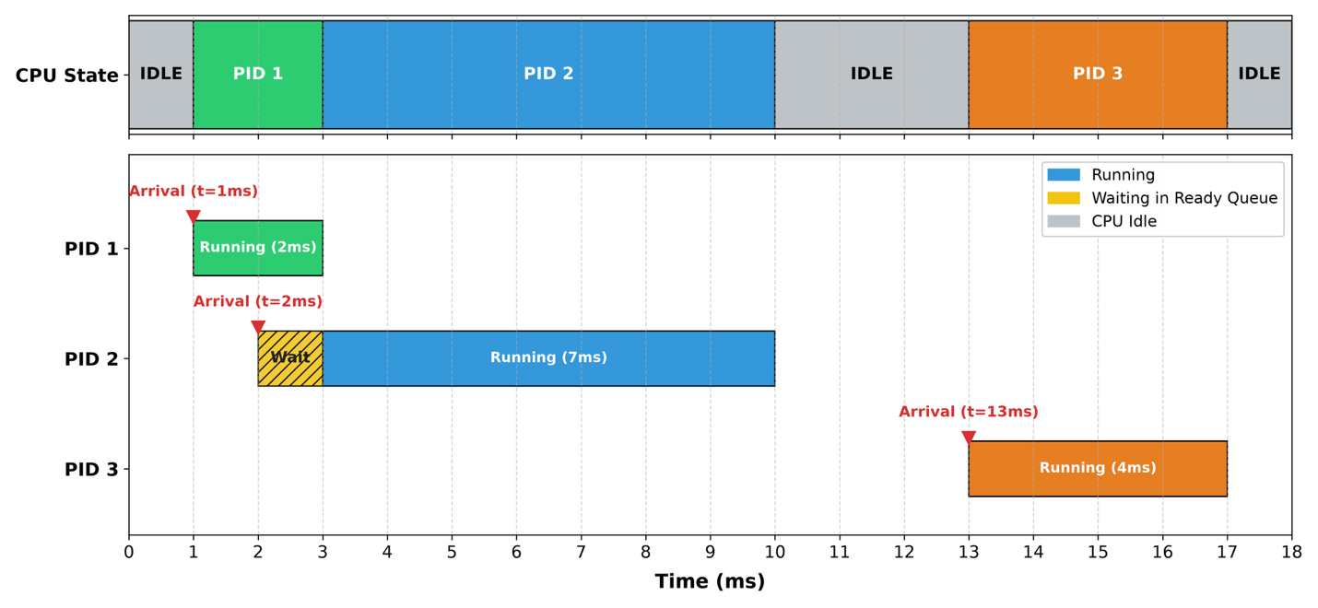

Process 1 arrives at 1ms; the CPU becomes busy with it.
At , The CPU is sitting IDLE, no process have arrived yet.
At , PID 1 has arrived, the CPU was idling, so it starts executing PID 1
At , PID 2 has arrived, the CPU is busy with PID 1, PID 2 has to wait
At , PID 1 has just been terminated, the CPU is now free, hence, it starts executing PID 2
At , PID 2 is still running...
Until , PID 2 has just been terminated, the CPU is now free. But there are no tasks, the CPU is idling.
At , PID 3 has arrived, the CPU was idling, so it starts executing PID 3
Until , PID 3 has just been terminated, the CPU is now free. But there are no tasks, the CPU is idling forever...

Notice, PID starts running from 1ms up until 2.999...ms i.e., just before 3ms.
We says PID 1 runs in the time segment (including 1ms but just before 3ms i.e., excluding 3ms)
PID 2 has a runs in the time segment
The CPU idling runs in the time segment
PID 3 runs in the time segment
Finally, the CPU again idles in the time segment
For our purpose, we can end the simulation just before 17ms, after that there are no more processes to be ran.

Output Format
Your program
1. Outputs a neatly formatted list of tuples to a markdown cell or file in the following format
process_id | arrival_time | requested_service_time
Process IDs must begin at 1 and increment sequentially as processes arrive.
Times should be printed in milliseconds (as integers). After that, the scheduling simulation should be run. For each CPU cycle (every millisecond), simulate whether the CPU is IDLE or BUSY. If running, which process ID is being run? Until all processes are finished. Output the CPU runtime range for each of the process. (see explanation)
Time (in ms) | CPU Status | PID
[ 0, 1) | IDLE |
[ 1, 3) | BUSY | 1
[ 3, 10) | BUSY | 2
[ 10, 13) | IDLE |
[ 13, 17) | IDLE | 3
2. Outputs the following statistics to a markdown cell or file as follows:
- Generated Averages: Based on your actual program output for the 1,000 generated processes , calculate and report the average arrival rate , , AND average service time , .
- Compare your computed value with the expected value for , and the computed value with the expected value for .
- Output the following metrics after the simulation in the Markdown Table (or notebook cell) as:
Statistics | Results
Total Complete Time |
Average Turnaround Time |
Average Waiting Time |
Overall CPU utilization |
Overall System Throughput |
Submit to Canvas:
- Generator Source Code Code Implementation in C, C++, or Python on Java. Add a PDF printout in case your source code is corrupted to ensure fair grading.
- Markdown document (submit both .md and .pdf) output. The tutorial is here: https://docs.github.com/en/get-started/writing-on-github/getting-started-with-writing-and-formatting-on-github/basic-writing-and-formatting-syntax
NOTE: if in Python Notebook, you can submit one notebook and its PDF printout, so two files, no need for four files

